LAB EXPERIMENT
SET 24: PRODUCT INVENTORY MANAGEMENT

Department | AIDS
Course Code / Course Name | DSA0602 / Data Handling and Visualization
Experiment | Data Visualization using R and Tableau
Name | D.HEMASREE
Register Number | 192524114
Date | 15 October 2026
Day | Thursday

Aim
To analyze product inventory data using a bar chart, a stacked bar chart and a scatter plot in R, and to build an interactive inventory dashboard using Tableau. Dataset: Product Inventory

Product ID | Product Name | Quantity Available | Category | Price (Rs.)
1 | Product A | 250 | Electronics | 40
2 | Product B | 175 | Electronics | 75
3 | Product C | 300 | Home | 25
4 | Product D | 200 | Home | 55
5 | Product E | 220 | Office | 50
The Category and Price columns are added for the stacked bar chart and the scatter plot.

PROGRAM 1: Bar Chart of Quantity Available
In R, create a bar chart to visualize the quantity of each product in the inventory. Label the axes and title the chart.
inventory <- data.frame( Product_ID = 1:5,
Product_Name = c("Product A", "Product B", "Product C",
"Product D", "Product E"), Quantity = c(250, 175, 300, 200, 220),
Category = c("Electronics", "Electronics", "Home", "Home", "Office"), Price = c(40, 75, 25, 55, 50)
)

barplot(inventory$Quantity,
names.arg = inventory$Product_Name, col = "steelblue",
xlab = "Product",
ylab = "Quantity Available",
main = "Quantity Available by Product", ylim = c(0, 350))

OUTPUT:
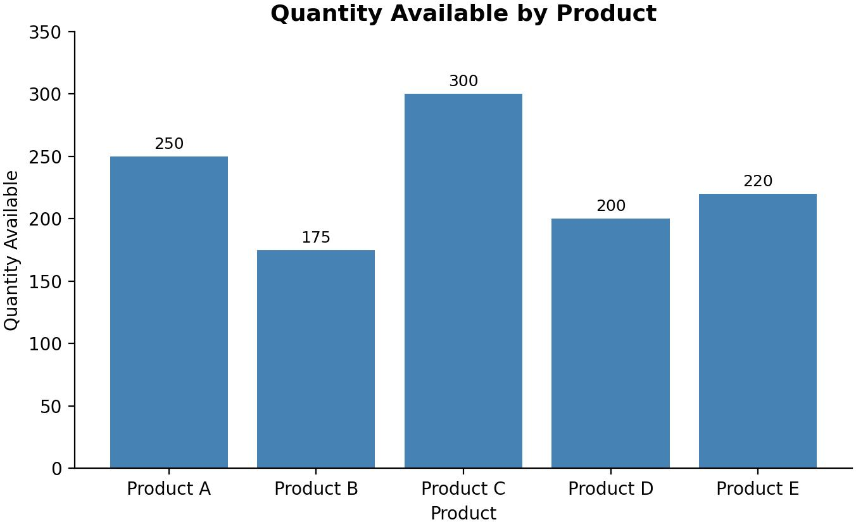
Output 1: Quantity Available by Product (Bar Chart)

Observation:
Product C has the highest stock at 300 units and Product B has the lowest at 175 units. Products A (250), E (220) and D (200) lie in between. The total inventory is 1,145 units, an average of 229 units per product.

PROGRAM 2: Stacked Bar Chart by Product Category
In R, generate a stacked bar chart to show the quantity of each product within different product categories.
library(ggplot2)

ggplot(inventory, aes(x = Category, y = Quantity, fill = Product_Name)) + geom_col() +
geom_text(aes(label = Quantity),
position = position_stack(vjust = 0.5)) + labs(title = "Quantity of Each Product by Category",
x = "Category",
y = "Quantity Available", fill = "Product")

OUTPUT:
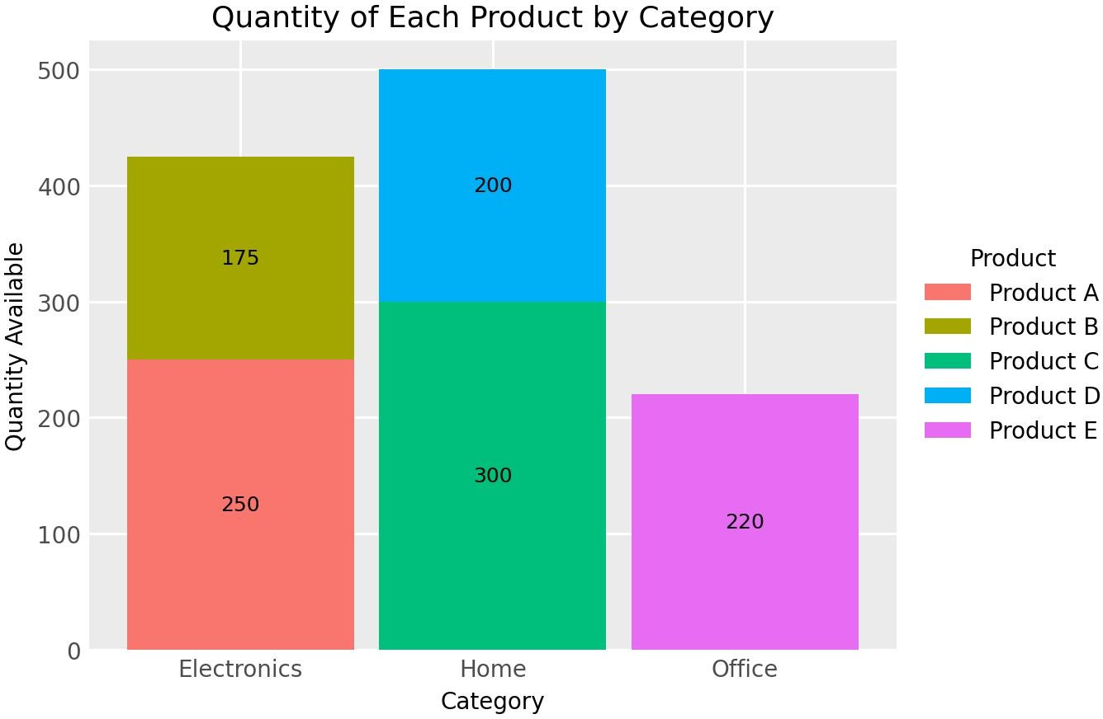
Output 2: Quantity of Each Product by Category (Stacked Bar Chart)

Observation:
Home holds the most stock with 500 units (Product C 300 and Product D 200), about 44% of the total. Electronics has 425 units (Product A 250 and Product B 175), about 37%, and Office has 220 units from Product E alone, about 19%.

PROGRAM 3: Interactive Inventory Dashboard in Tableau
In Tableau, build a dashboard combining the bar chart and the stacked bar chart for interactive exploration of inventory data.

Steps in Tableau
- Save the data as an Excel or CSV file and connect to it in Tableau (Connect > Microsoft Excel / Text file).
- Sheet 1 (Bar Chart): Drag Product Name to Columns and Quantity Available to Rows (SUM). Drag Product Name to Color and add Quantity Available to Label. Rename the sheet "Quantity by Product".
- Sheet 2 (Stacked Bar Chart): Drag Category to Columns and Quantity Available to Rows (SUM). Drag Product Name to Color so that the bars are stacked, and add Quantity Available to Label. Rename the sheet "Quantity by Category".
- Create a new Dashboard (Dashboard > New Dashboard), set the size to Automatic, and drag the two sheets onto the dashboard area.

- Add interactivity: select each chart and click Use as Filter, so clicking a product or category in one view filters the other. Add Category and Product Name filters (Show Filter > Apply to Worksheets > All Using This Data Source).
- Add the title "Product Inventory Dashboard" and test the filters in Presentation Mode.

OUTPUT:
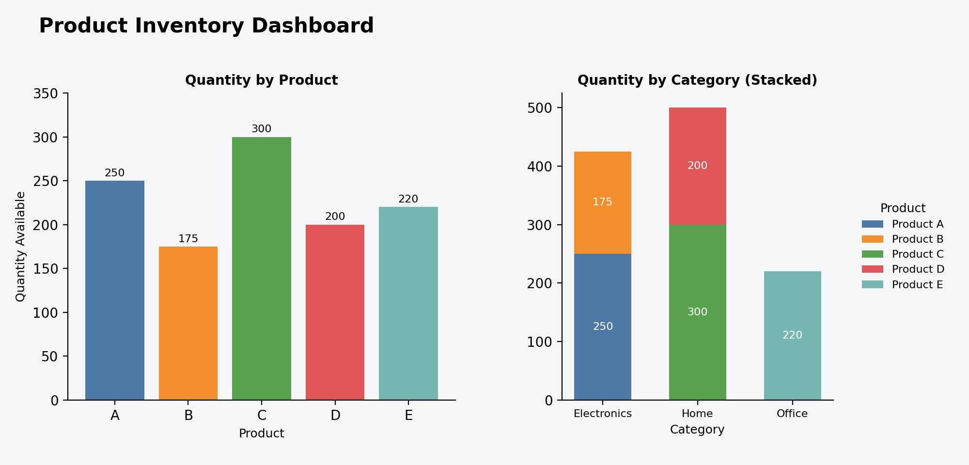
Output 3: Interactive Product Inventory Dashboard (Tableau)

Observation:
The dashboard shows the quantity of each product and the category-wise stacked quantities together. Clicking a bar or a category filters the other view, so stock levels can be compared by product and by category.

PROGRAM 4: Scatter Plot of Price vs Quantity Available
In R, create a scatter plot to explore the relationship between product price and quantity available. Explain any insights.
ggplot(inventory, aes(x = Price, y = Quantity)) + geom_point(size = 4, colour = "steelblue") + geom_text(aes(label = Product_Name), vjust = -1) + geom_smooth(method = "lm", se = FALSE, colour = "red") + labs(title = "Price vs Quantity Available",
x = "Price (Rs.)",
y = "Quantity Available")

cor(inventory$Price, inventory$Quantity)

OUTPUT:
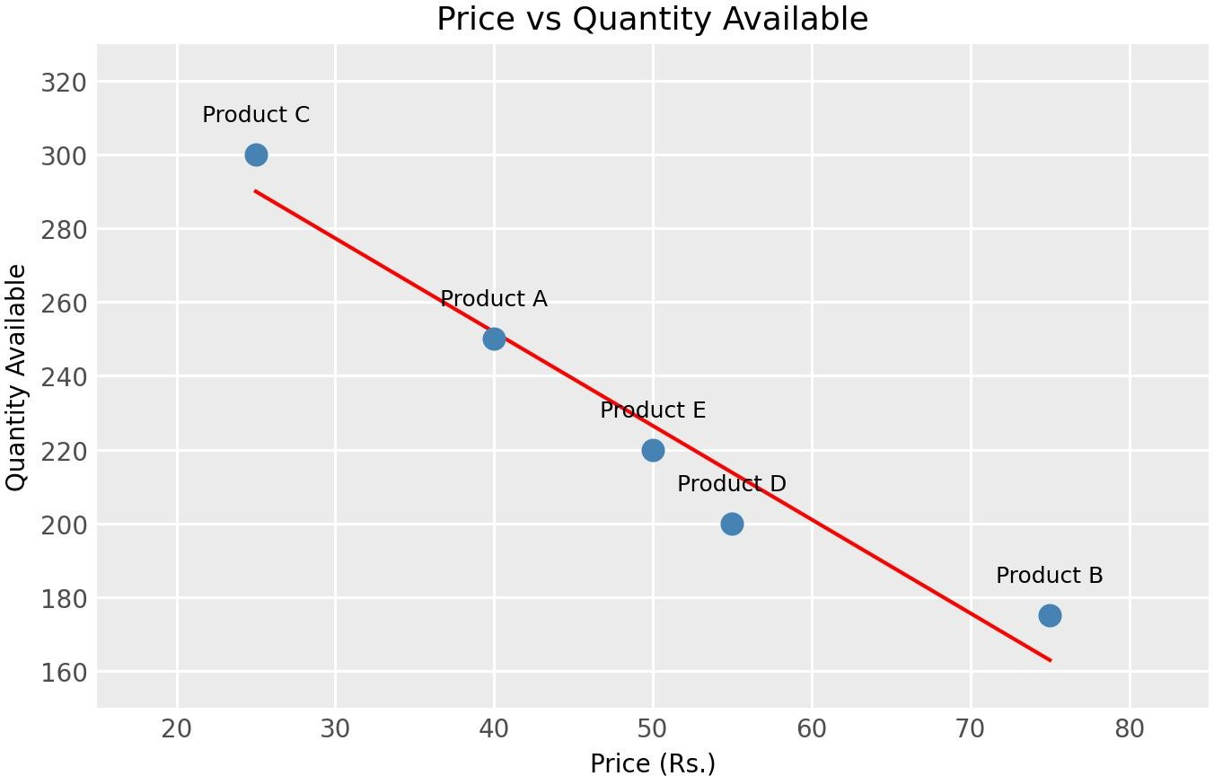

Output 4: Price vs Quantity Available (Scatter Plot)
[1] -0.9738925
Output 4a: Correlation between Price and Quantity (R Console)

Observation:
The points fall along a downward line and the correlation coefficient is about -0.97, a strong negative relationship. Low-priced products are stocked in larger quantities (Product C at Rs. 25 has 300 units and Product A at Rs. 40 has 250 units), while the highest-priced product (Product B at Rs. 75) has the lowest stock of 175 units. On average, each Rs. 1 increase in price goes with about 2.5 fewer units in stock. This suggests that cheaper items are bought and held in bulk, while costly items are stocked in smaller quantities to limit the money tied up in inventory. With only five products, this pattern shows association and not cause.

Procedure
- Define the product, quantity, category and price values in R as a data frame.
- Use barplot() to create the bar chart of the quantity available for each product.
- Use ggplot2 with geom_col() to draw the stacked bar chart of products within categories.
- Load the inventory file into Tableau and build the bar chart and stacked bar chart worksheets.
- Combine the worksheets in a Tableau dashboard and add filters and actions for interactivity.
- Use ggplot2 with geom_point() and geom_smooth() to draw the scatter plot, and use cor() to measure the relationship between price and quantity.

RESULT:
The product inventory data was successfully analyzed using a bar chart and a stacked bar chart in R, and the relationship between price and quantity was explored with a scatter plot. An interactive Tableau

dashboard was also created, combining both charts so that users can explore the inventory by product and by category.

Key Functions and Tools Used

Function / Tool | Purpose
data.frame() | Creates the inventory table.
barplot() | Creates the bar chart of quantity by product.
ggplot() / geom_col() | Creates the stacked bar chart by category.
geom_point() / geom_smooth() | Creates the scatter plot with a trend line.
cor() | Calculates the correlation between price and quantity.
Tableau Dashboard | Combines worksheets with filters and actions.

